**Hydrological Cycle**

* Water needs to be replenished, purified and circulated again and again so that it can perform its functions.
* Nature does this job through a process called Water cycle.
* The water cycle, also known as the hydrologic cycle or the hydrological cycle, describes the continuous movement of water on, above and below the surface of the Earth.
* The water moves from one reservoir to another, such as from rivers to ocean or from ocean to atmosphere by physical process of:
  + Evaporation
  + Condensation
  + Precipitation
  + Surface runoff
  + Infiltration
  + Transpiration or Evapotranspiration
* The water cycle goes through different phases:
  + Solid
  + Liquid
  + Vapour
* Over 4 spheres:
  + Atmosphere
  + Lithosphere
  + Hydrosphere
  + Biosphere

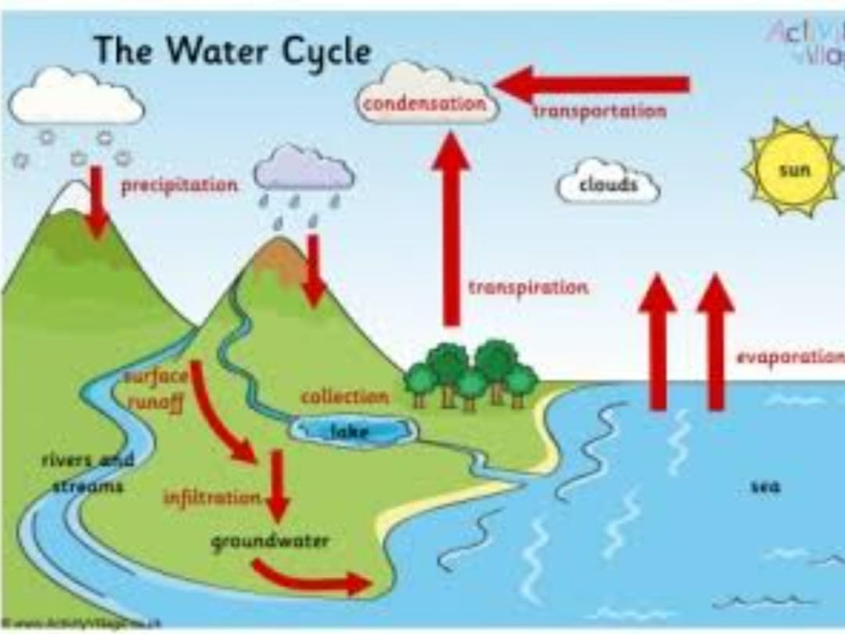

#### ****1. Evaporation:****

* Evaporation is the process where a liquid changes from its liquid state to a gaseous state. Liquid water becomes water vapour. Temperature is the primary factor for evaporation.
* During the water cycle the water of the oceans and freshwater bodies, such as lakes and rivers, is warmed by the sun and evaporates. During the process of evaporation, impurities in the water are left behind. As a result, the water that goes into the atmosphere is cleaner than it was on Earth.

#### 2. Condensation:

* Condensation is the opposite of evaporation. Condensation is the process where a gas is changed into a liquid. Condensation occurs when the temperature of the vapour decreases.
* The water droplets formed from condensation are very small and they remain suspended in the atmosphere. There millions of droplets of suspended water form clouds in the sky or fog at ground level. Water condenses into droplets only when there are small dusts particles present around.

#### 3. Precipitation:

* When the temperature and atmospheric pressure are right, the small droplets of water in clouds form larger droplets or raindrops and it is called precipitation. The raindrops fall to earth.
* As a result of evaporation, condensation and precipitation, water travels from the surface of the Earth goes into the atmosphere, and returns to Earth again.

#### 4. Surface Runoff:

* Much of the water that returns to Earth as precipitation runs off the surface of the land and flows down-hill into streams, rivers, ponds and lakes. Small streams flow into the ocean. Surface runoff is an important part of the water cycle because, through surface runoff, much of the water returns again to the oceans, where a great deal of evaporation occurs.

#### 5. Infiltration:

* Infiltration is an important process where rain water soaks into the ground, through the soil and underlying rock layers. Some of this water ultimately returns to the surface at springs or in low spots downhill. Some of the water remains underground and is called groundwater.
* As the water infiltrates through the soil and rock layers, many of the impurities in the water are filtered out. This filtering process helps in cleaning of the water.

#### 6. Transpiration or Evapotranspiration:

* This is performed by plants. As plants absorb water from the soil, the water moves from the roots through the stems to the leaves. Once the water reaches the leaves, some of it evaporates from the leaves, adding to the amount of water vapour in the air. This process of evaporation through plant leaves is called transpiration. In large forests, an enormous amount of water will transpire through leaves.

**Urban Stormwater management**

* Urban Stormwater management means to manage surface runoff. It can be applied in rural areas, but it is essential in urban areas where run-off can infiltrate because the surfaces doesn’t allow to flow liquid(impermeable).
* Traditional Stormwater management was mainly to drain high peak flow away.
* Modern approaches aim to recycle the natural water cycle, i.e to store runoff water (retention basins) for certain time to recharge ground water. And to use collected water for irrigation or household supply.

By using different stormwater management systems rainwater can be caught and slowly released into the ground, rivers, stream without causing any flooding or erosion.

* There are several techniques to manage runoff. They are divided into 2 types:
  + Storage Type devices
  + Infiltration Type devices

Storage Type devices:

**Retention pond:**

* Retention ponds is also known as Retention basin/wet pond.
* Retention ponds holds water all the time.

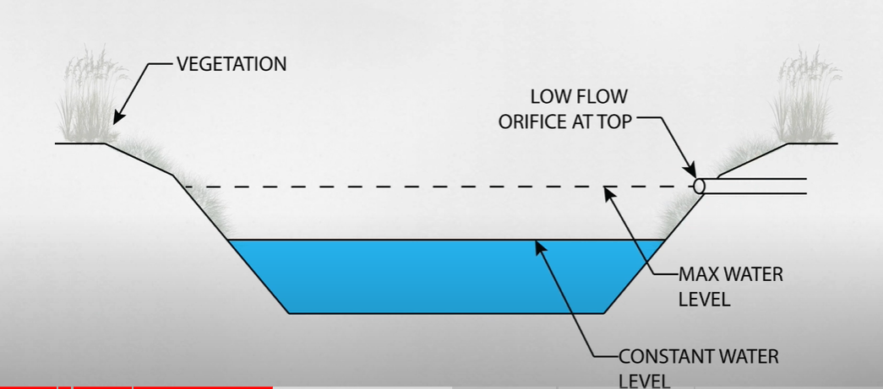

* In retention pond there is always some water, and the water allowed on it is a low-flow orifice.
* Which is basically train pipe which slowly releases the overflow water into ground, water, rivers.
* As rain falls it will slowly rise and releases the water as needed to maintain a desired level.

**Detention ponds:**

* Detention ponds doesn’t have water in it at all times.
* Detention ponds holds the water for a while after the rain, then releases it.

It usually covered with a vegetation.

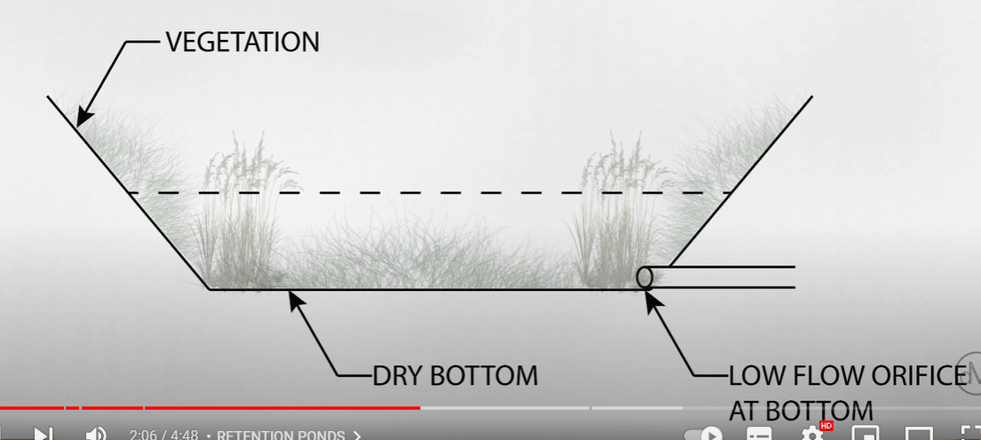

It also has a low-flow orifice but it has at the bottom of the pond.

Rainwater harvesting:

* Rainwater harvesting (RWH) is the collection and storage of rain, rather than allowing it to run off.
* Rainwater is collected from a roof-like surface and redirected to a tank.

Infiltration Type devices:

Infiltration Trenches:

* They are shallow ditches, used to slow down or reduce the process of erosion.

**Grass Filter Stripes**

Grass filter stripes are densely vegetated, uniformly graded areas that treat surface flow from adjacent impervious areas. Grass filter stripes function by slowing runoff velocities, trapping sediment and other pollutants and providing a modest infiltration.

#### Infiltration Basin

An infiltration basin (also called infiltration pond) is a facility constructed within highly permeable soils that provides temporary storage of stormwater runoff (see also [**surface groundwater recharge**](https://sswm.info/water-nutrient-cycle/reuse-and-recharge/hardwares/recharge-and-disposal/surface-groundwater-recharge)). An infiltration basin does not normally have a structural outlet (like detention basins) to discharge runoff from the stormwater quality design storm. Instead, outflow from an infiltration basin is through the surrounding soil.

**Components of RWH**

The components of Rainwater harvesting are:

1. Catchments
2. Coarse mesh
3. Gutters
4. Conduits
5. First flush
6. Filters
7. Storage tanks and
8. Recharge structures

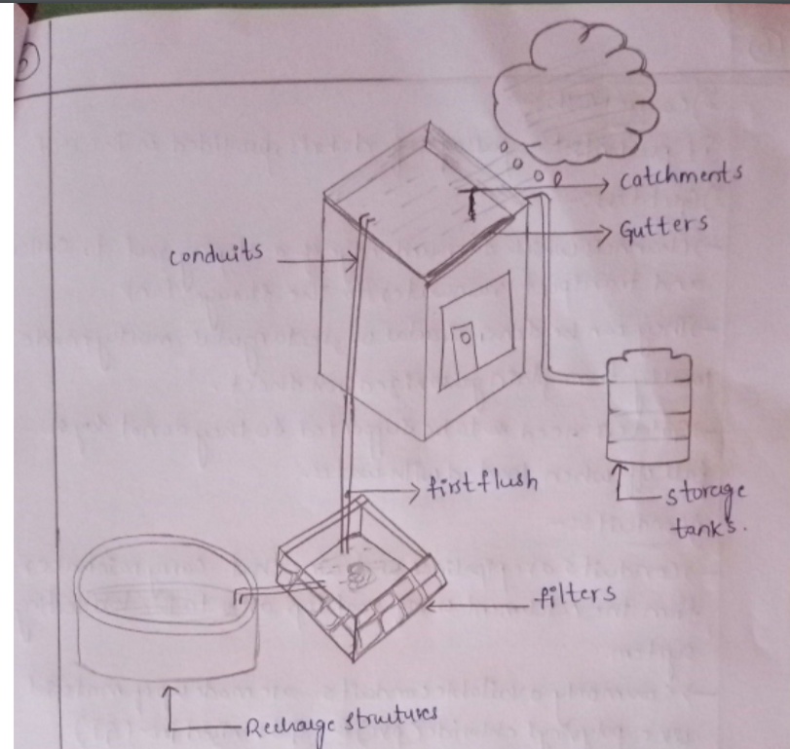

1. Catchments
   * The surface which directly receives the rainfall and provides water to the system is called catchment area.
   * It can be paved area like terrace or courtyard of a building, or an unpaved area like lawn or open ground.
   * A roof made of reinforced cement concrete (RCC), galvanized iron or corrugated sheets can be used.
2. Coarse mesh
   * After collecting water in the catchment area, we need to remove the floating materials. So, we use coarse mesh to remove those materials.
3. Gutters
   * Channels which surround edge of a sloping roof to collect and transport rain-water to storage tank.
   * They can be semi-circular or rectangular.
   * Gutters need to be supported so they don’t fall-off when loaded with water.
4. Conduits
   * Conduits is a kind of piping system that carry rainwater from catchment area or roof-top area to the harvesting system.
   * We carry water from higher elevation to lower elevation with good arrangement of piping system.
5. First-Flush
   * When we are collecting rain-water it is more polluted water. If we directly send the collected rain-water to storage or recharge systems. Then in the storage or rechargement system, it requires some other implementation to remove the pollution.
   * We ensure the flushing out pollutants before sending the collected rain-water into the storage.
6. Filter
   * It is mainly related to suspended particles.
   * It is used to remove suspended pollutants, debris from rain-water from rainwater collected from roof-top water.
   * Various types of filters used are charcoal filter, sand filter, etc
   * Filter means different layers of small particles like sand, smaller wide materials are used so that it can easily remove the suspended particles.
7. Storage tanks
   * There are various options available for construction of storage tanks with respect to shape, size, position of tank
   * Depending on the availability of land storage tanks are built.
   * Ex: Shape: Cylindrical, square, rectangular
   * After the filteration is applied we can store the water in underground depending on the availability of the land.
8. Recharge systems
   * And with the excess amount of water, it can be used for charging.
   * Some commonly used recharging methods are recharging of dugwells and abandoned tubewells.

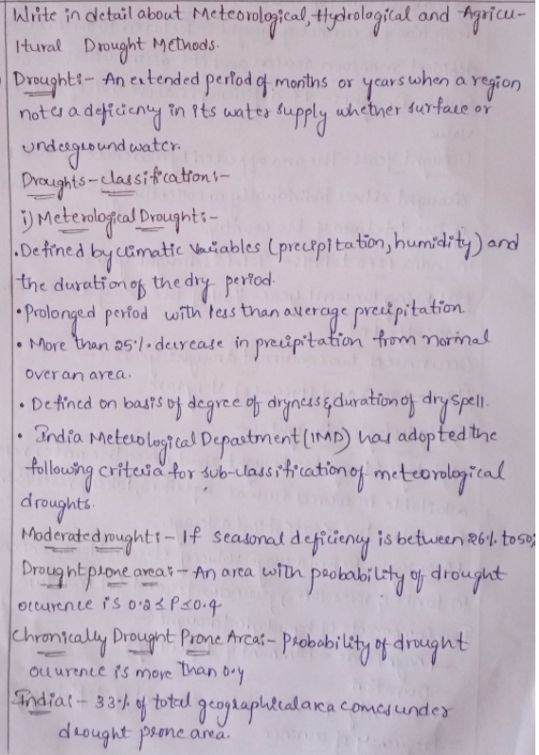

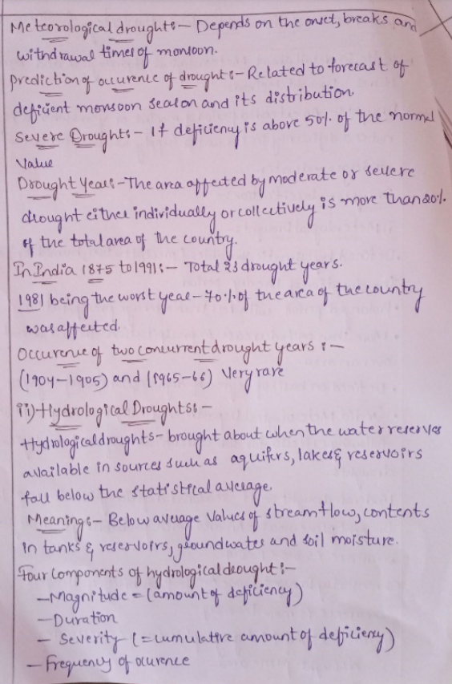

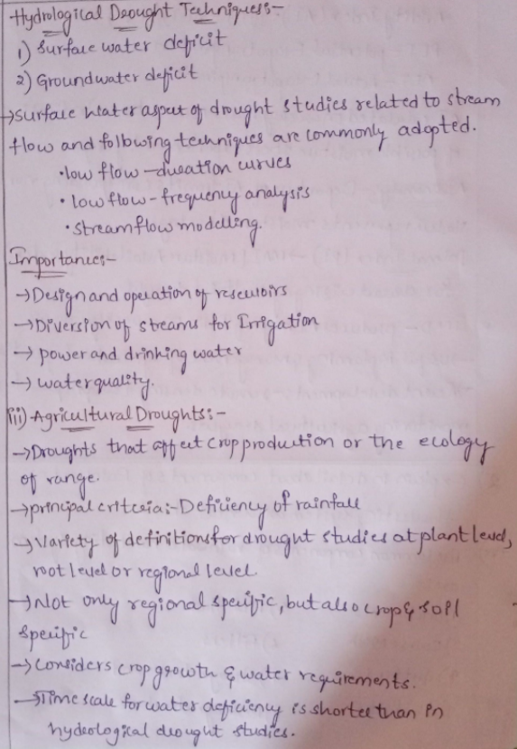

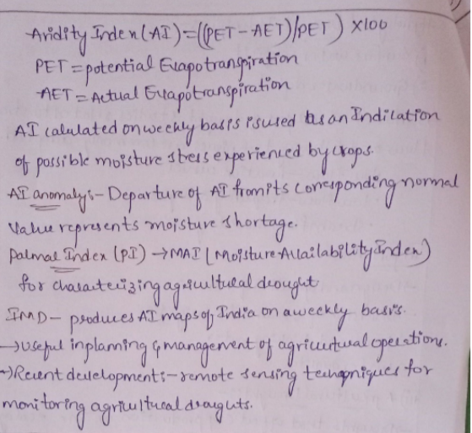

* An aridity index (AI) is a numerical indicator of the degree of dryness of the climate at a given location.
* palmar index also known as Palmer Drought Severity Index (PDSI)
* The Palmer Drought Severity Index (PDSI) uses readily available temperature and precipitation data to estimate relative dryness.

**Himachal Pradesh**

* Installation of rainwater harvesting system has been made mandatory for all buildings to be constructed in urban areas of the state and no building plan without rainwater harvesting system can be approved.
* Construction of rainwater harvesting system has also been made mandatory for all schools, govt. buildings and rest houses, upcoming industries& bus stands.

**Ahmedabad**

* In 2002, the Ahmedabad Urban Development Authority (AUDA) had made rainwater harvesting mandatory for all buildings covering an area of over 1,500 square metres.
* According to the rule, for a cover area of over 1,500 square metres, one percolation well is mandatory to ensure ground water recharge. For every additional 4,000 square metres cover area, another well needs to be built.

**Bangalore**

* Every owner or occupier of a building with site area 2400 sq. feet or above or every owner who proposes to construct a building with site area more than 1200 sq. feet shall provide rain water harvesting structures in such a manner as provided in the regulations.

**Chennai**

* Rainwater harvesting has been made mandatory in three storied buildings.
* All new water and sewer connections are provided only after the installation of rainwater harvesting systems.

**Kerala**

* Government of Kerala included rainwater harvesting structures in new constructions.

**New Delhi**

* Since June 2001, the Ministry of Urban affairs and Poverty Alleviation has made rainwater harvesting mandatory in all new buildings with a roof area of more than 100 sq m and in all plots with an area of more than 1000 sq.m, that are being developed.
* The Central Ground Water Authority (CGWA) has made rainwater harvesting mandatory in all institutions and residential colonies in notified areas.
* This is also applicable to all the buildings in notified areas that have tubewells. The deadline for this was for March 31, 2002.
* The CGWA has also banned drilling of tubewells in notified areas

**Indore (Madhya Pradesh)**

* Rainwater harvesting has been made mandatory in all new buildings with an area of 250 sq m or more.
* A rebate of 6 per cent on property tax has been offered as an incentive for implementing rainwater harvesting systems.

**Kanpur (Uttar Pradesh)**

* Rainwater harvesting has been made mandatory in all new buildings with an area of 1000 sq m or more.
* Government order on rainwater harvesting in Kanpur

**Hyderabad (Andhra Pradesh)**

* Rainwater harvesting has been made mandatory in all new buildings with an area of 300 sq m or more.
* Andhra Pradesh Water, Land and Trees Act, 2002
* Government order for all Municipalities in Andhra Pradesh

**Rajasthan**

* The state government has made rainwater harvesting mandatory for all public and establishments and all properties in plots covering more than 500 sq m in urban areas.

**Mumbai**

* The state government has made rainwater harvesting mandatory for all buildings that are being constructed on plots that are more than 1,000 sq m in size.
* The deadline set for this was October, 2002.

**Gujarat**

* The state roads and buildings department has made rainwater harvesting mandatory for all government buildings